**CS-114 - Fundamental of Programing**

Lab Manual # 04

Lab Tasks

**Course Instructor:** Khawaja Fahad Iqbal

**Lab Instructor:** Muhammad Affan

**Student Name:** Muhammad Talha Kashif

**CMS ID:** 454135

#include <iostream>

using namespace std;

Lab Task 1

int main() {

int i,sum,num;

sum=0;

while(i<10)

{

cout<<"Enter a number:";

cin>>num;

sum=sum+num;

i++;

}

cout<<"sum is:"<<sum;

return 0;

}

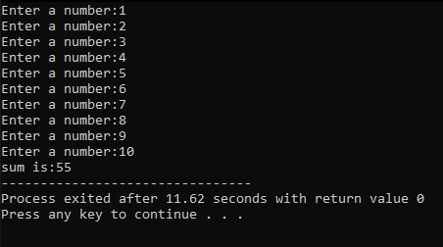

#include <iostream>

Lab Task 2

using namespace std;

int main() {

int num,table,multiple,i;

cout<<"Enter a number:";

cin>>num;

multiple=1;

for(i=0;i<=9;i++)

{

table=num*multiple;

cout<<num<<" x "<<multiple<<" = "<<table<<endl;

multiple++;

}

return 0;

}

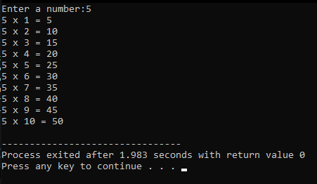

#include <iostream>

using namespace std;

Lab Task 3

int main() {

int num,result,i;

cout<<"Enter a number:";

cin>>num;

result=num;

i=num;

cout<<num<<"! = "<<num;

while(i>1)

{

num--;

result=result*num;

cout<<" x "<<num;

i--;

}

cout<<" = "<<result;

return 0;

}

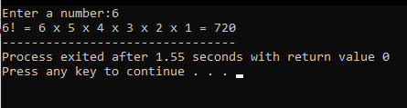

#include <iostream>

using namespace std;

Lab Task 4

int main() {

int n1,n2,next,terms,i;

cout<<"Enter number of terms:";

cin>>terms;

cout<<" "<<endl;

cout<<"Fibonacci sequence of "<<terms<<" terms:-"<<endl;

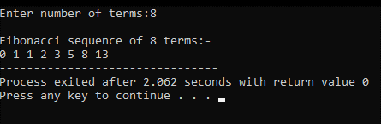

n1=0;

n2=1;

for(i=0;i<terms;i++)

{

if(i==0)

{

cout<<n1<<" ";

}

else if(i==1)

{

cout<<n2;

}

else

{

next=n1+n2;

n1=n2;

n2=next;

cout<<" "<<next;

}

}

return 0;

}